**F Distribution**

If *V* 1 and *V* 2 are two independent random variables having the [Chi-Squared distribution](http://www.r-tutor.com/node/60) with *m*1 and *m*2 degrees of freedom respectively, then the following quantity follows an **F distribution**with *m*1 *numerator degrees of freedom*and *m*2 *denominator degrees of freedom*, *i.e.*, (*m*1*,m*2) degrees of freedom.

F = V1∕m1-~ F (m ,m )
    V2∕m2      1  2


Here is a graph of the F distribution with (5, 2) degrees of freedom.

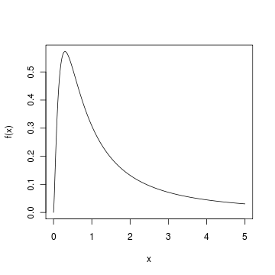

#### Problem

Find the 95*th* [percentile](http://www.r-tutor.com/node/38) of the F distribution with (5, 2) degrees of freedom.

#### Solution

We apply the quantile function qf of the F distribution against the decimal value 0.95.

> qf(.95, df1=5, df2=2)   
[1] 19.296

#### Answer

The 95*th* percentile of the F distribution with (5, 2) degrees of freedom is 19.296.